Programs: Electrical & Computer Engineering

|  |  |
| --- | --- |
| Course Number | **ELE635** |
| Course Title | **Communication Systems** |
| Semester/Year | **Winter 2019** |
| Instructor | **Ngok-Wa Ma** |

|  |  |
| --- | --- |
| **Lab Report No.** | **2** |

|  |  |
| --- | --- |
| Report Title | **Amplitude Modulation and Demodulation** |

|  |  |
| --- | --- |
| Section No. | **10** |
| Group No. | **01** |
| Submission Date | **12/03/19** |
| Due Date | **12/03/19** |

|  |  |  |
| --- | --- | --- |
| Name | Student ID | Signature\* |
| Vatsal Shreekant | 71363 |  |

(Note: remove the first 4 digits from your student ID)

*\*By signing above you attest that you have contributed to this submission and confirm that all work you have contributed to this submission is your own work. Any suspicion of copying or plagiarism in this work will result in an investigation of Academic Misconduct and may result in a “0” on the work, an “F” in the course, or possibly more severe penalties, as well as a Disciplinary Notice on your academic record under the Student Code of Academic Conduct, which can be found online at:*

[*www.ryerson.ca/senate/current/pol60.pdf*](http://www.ryerson.ca/senate/current/pol60.pdf)*.*

# **A1**

I 
5.oow 
2 
5.85% 
ear 
Dis I 
500. ops/ 
Auto 
Recall Menu 
eca 
___Setup 
oa rom 
e2setupAB 
4389 
KEYSIGHT 
TECHNOLOGIES 
Ac uisition 
Normal 
10.0Msa/s 
Channels 
1.00:1 
Push to Se 
easurements 
5eov 
inte 
Freq(l): 
1 .0058kHz 
Freq(2): 
1.2500kHz 
Pk-Pk(2): 
293mv 
ress o 
Recall 

# **A2**

1 
5.oow 
2 
1289/ 
5.85* 
500.07 
Auto 
1 
4389 
KEYSIGHT 
TECHNOLOGIES 
Acquisition 
Normal 
10.0Msa/s 
Channels 
1.00:1 
Recall Menu 
Measurements 
pk.pk(l): 
2.6V 
Freq(l): 
504.90Hz 
Freq(2): 
9.99kHz 
Pk.Pk(2): 
247mv 
ress to 
Recall 

# **B1 Table 1.1**

|  |  |  |  |  |  |  |  |  |
| --- | --- | --- | --- | --- | --- | --- | --- | --- |
| **M(t)** VPP | **AMAX** mV | **AMIN** mV | **α** mV | **β** mV | **S** mVrms | **C** mVrms | **SdB** dBV | **CdB** dBV |
| 2 | 183 | 79.8 | 118.3 | 297.5 | 16.59 | 68.23 | -35 | -23.125 |
| 4 | 169 | 93.10 | 134 | 274 | 13.7 | 69.1 | -36.5 | -22.5 |
| 6 | 188 | 75.90 | 89.1 | 313 | 19.4 | 69.1 | -34.37 | -22.5 |
| 8 | 211 | 55.125 | 49.2 | 355.7 | 26.01 | 69.1 | -31.2 | -23.5 |
| 10 | 230 | 36.50 | 10 | 390.9 | 31.9 | 69.1 | -29.5 | -23.5 |
| 12 | 248 | 47.90 | 39 | 434 | 31.9 | 69.1 | - | - |
| 14 | 262 | 59.60 | 39 | 458 | 31.9 | 69.1 | - | - |
| 16 | 262 | 55.12 | 39 | 458 | 31.9 | 69.1 | - | - |

500.07 
1 
1 
2 
5.oow 
2 
128e/ 
5.85% 
C ear 
Auto 
ear, t 
All 
o.ov 
KEYSIGHT 
TECHNOLOGIES 
Acquisition 
Normal 
10.0Msa/s 
Channels 
1.00•.1 
1.0011 
easurements 
Min(2): 
Max(2): 
-ii6mv 
178mv 
Clear Measurements Menu 
ea 
Min(2) 
Max(2 
Clear Meas 
< Non B > 

1.52V1 
2 
569/ 
Cursors Menu 
Manual 
Stop 
X2: 8.41700,1 
KEYSIGHT 
TECHNOLOGİES 
Acquisition 
Normal 
50,wsa/s 
Channels 
ı.oo:ı 
Cursors 
+17,11900V 
AY(2): 
+118.300mV 
Ml: -30.BOOmV 
Y2•. 87.500mV 

1 
5.oow 
2 
1169/ 
Digital Storage Oscilloscope 
5.85% 
500. ops/ 
2 GSa/s 
Auto 
Cursors Menu 
Manual 
4389 
KEYSIGHT 
TECHNOLOGIES 
Acquisition 
Normal 
10.0MSa/s 
Channels 
1.00:1 
1.0011 
Cursors 
+20. OOOOOOOOOkHz 
AY(M): 
+24.350mV 
m 
Math 
X2: 20.OOOOOOOOOkHz 
Y2 16.589mV 

1 
5.oow 
2 
5.856; 
ettlngs 
500.07 
Auto 
eas 
1 
4389 
KEYSIGHT 
TECHNOLOGIES 
Acquisition 
Normal 
10.0Msa/s 
Channels 
1.00--1 
1.0011 
Measurements 
Pk-Pk(lY. 
Freq(l): 
1 .0002kHz 
Freq(2): 
1.4286kHz 
Pk-Pk(2): 
298mv 
Measurement Menu 
ource 
ear 

**Table 1.2**

|  |  |  |  |  |
| --- | --- | --- | --- | --- |
| **M(t)** VPP | **Method 1 μ** | **Method 2 μ** | **Method 3 μ** | **Method 4 μ** |
| 2 | 0.3920 | 0.4310 | 0.4863 | -12.2826 |
| 4 | 0.2890 | 0.3431 | 0.3965 | -14.0551 |
| 6 | 0.4240 | 0.5568 | 0.5615 | -11.0335 |
| 8 | 0.5940 | 0.7570 | 0.7528 | -8.4867 |
| 10 | 0.7260 | 0.9501 | 0.9233 | -6.7137 |
| 12 | 0.6760 | 0.8351 | 0.9233 | -6.7137 |
| 14 | 0.6290 | 0.8431 | 0.9233 | -6.7137 |
| 16 | 0.6520 | 0.8431 | 0.9233 | -6.7137 |

# **B2**

All the methods for calculating the modulation index are applicable for the specified usage. The efficiency of each method, however, is different and therefore brings produces varying accuracies. The methods implemented in the 3rd and the 4th calculations, respectively, are not quite accurate as the values can be clobbered due to the height of the peaks, as is witnessed in the plots. This is the case for both Vrms case and dBV case. The other two methods offer multiple values of measurements for further calculation to produce more accurate results.

# **B3: Table 1.3**

|  |  |  |  |
| --- | --- | --- | --- |
| **M(t)** VPP | **PS** W | **PC**  W | **Efficiency** % |
| 2 | 0.0086 | 0.0007 | 7.1585 |
| 4 | 0.0086 | 0.0004 | 4.0242 |
| 6 | 0.0087 | 0.0008 | 8.2754 |
| 8 | 0.0089 | 0.0015 | 14.6419 |
| 10 | 0.0089 | 0.0023 | 20.8607 |
| 12 | 0.0082 | 0.0036 | 30.5634 |
| 14 | 0.0129 | 0.0026 | 16.5305 |
| 16 | 0.0126 | 0.0027 | 17.5458 |

# **B4**

To use an envelope detector for these purposes, then: [Ac + Am] > 0.

$$m\left(t\right)= [0.1+ A_{m}cos2πf_{m}t]$$

The minimum value of Am will be evaluated at:

$$0.1-A_{m}≥0$$

$$0.1≥A_{m}$$

To maximize power efficiency, then the amplitude for the messenger signal must be as high as possible. Therefore, the amplitude for the messenger signal to use would be 0.1.

# **C1**

$$5\%≤μ≤95\% μ_{+}=125\%$$

$$125\%= \frac{A_{max}-A_{c}}{A_{c}} A_{max}=2.25A_{c}$$

$$μ_{-}= \frac{A_{c}-A_{min}}{A_{c}} A_{min}=-A_{c}(2u_{-}-1)$$

$$μ= \frac{A_{max}-A_{min}}{2A_{c}}=0.625+μ_{-}$$

$$∴0.225≤μ_{-}≤0.325$$

$$0.225=\frac{A_{c}-A_{min}}{A_{c}} A_{min}={0.775*A}_{c}$$

$$0.325=\frac{A_{c}-A_{min}}{A_{c}} A_{min}={0.675*A}_{c}$$

$$A_{c}+A_{min}≥0$$

$$A_{c}+0.775*A_{c}≥0$$

$$A_{c}+0.675*A_{c}≥0$$

$$∴A_{c}≥0$$

This proves that no matter what the carrier amplitude is, the radio stations can broadcast a signal with a μ+ of 125%

# **C2**

The Envelop Detector Rectifier is able to reproduce the signal with lesser components and can be implemented to serve the purpose of creating cheap radio receivers for AM signal.

# **C3**

Regardless of the modulation index, the coherent detector demodulated the modulated signal. Any signal, that is not over-modulated, can be demodulated by the envelope detector. Therefore, the coherent detector is more than effective demodulation method.

# **C4**

The Phase Locked Loop seems to adjust the carrier frequency, as is observed from the calculations. The oscillator will suppress any signal that is not an ideal frequency.

**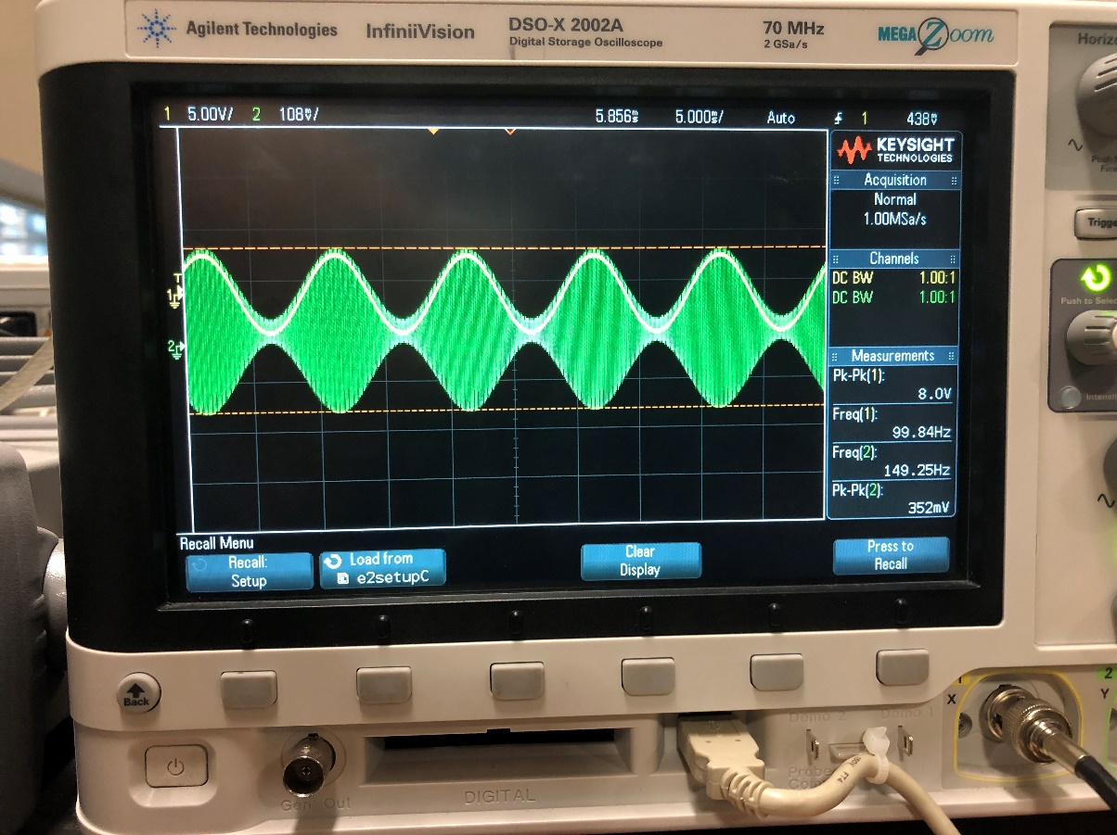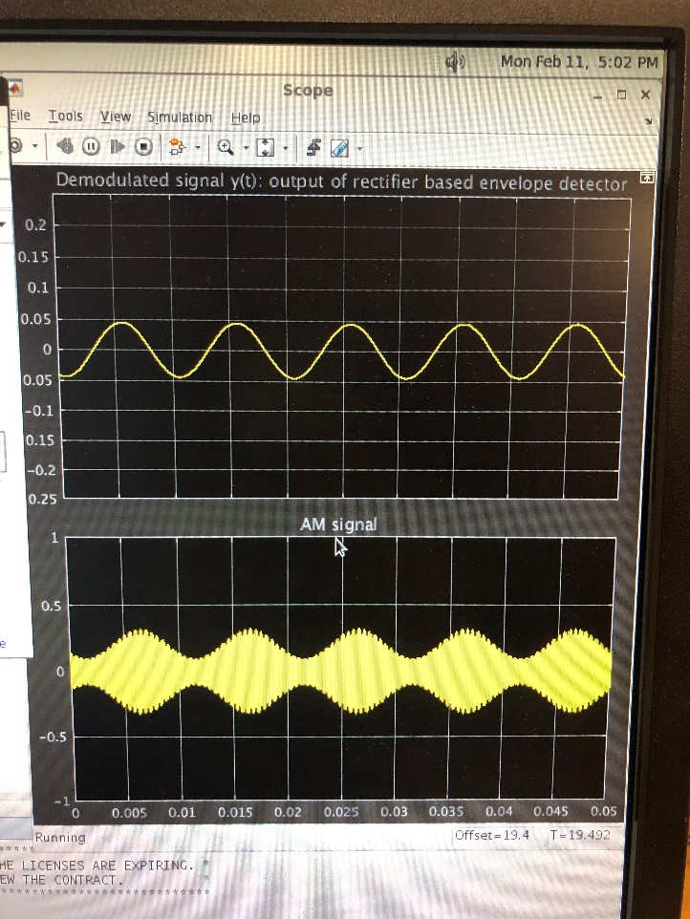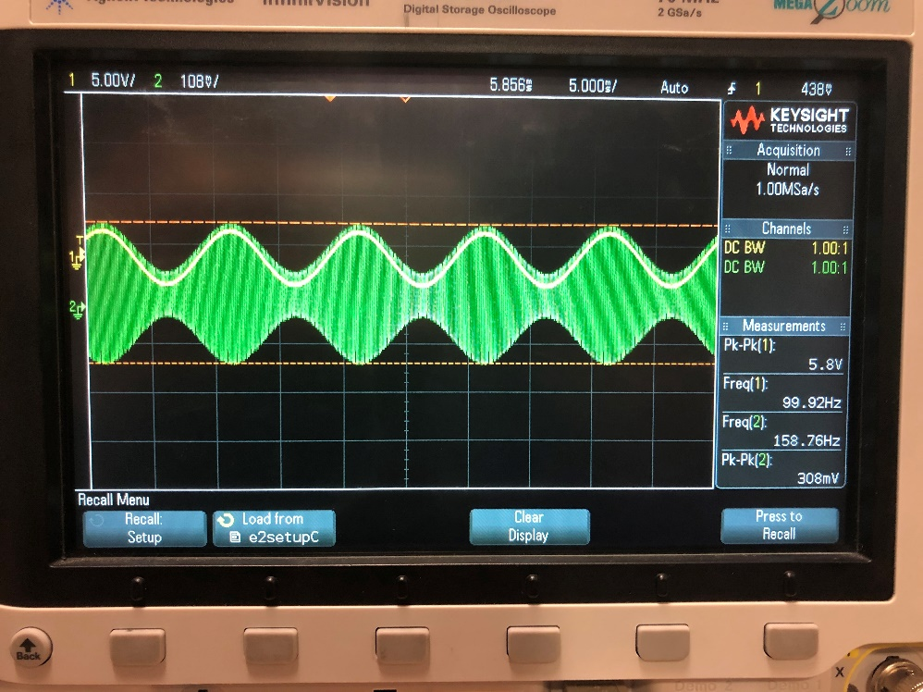Rectifier Based Envelope Detector**

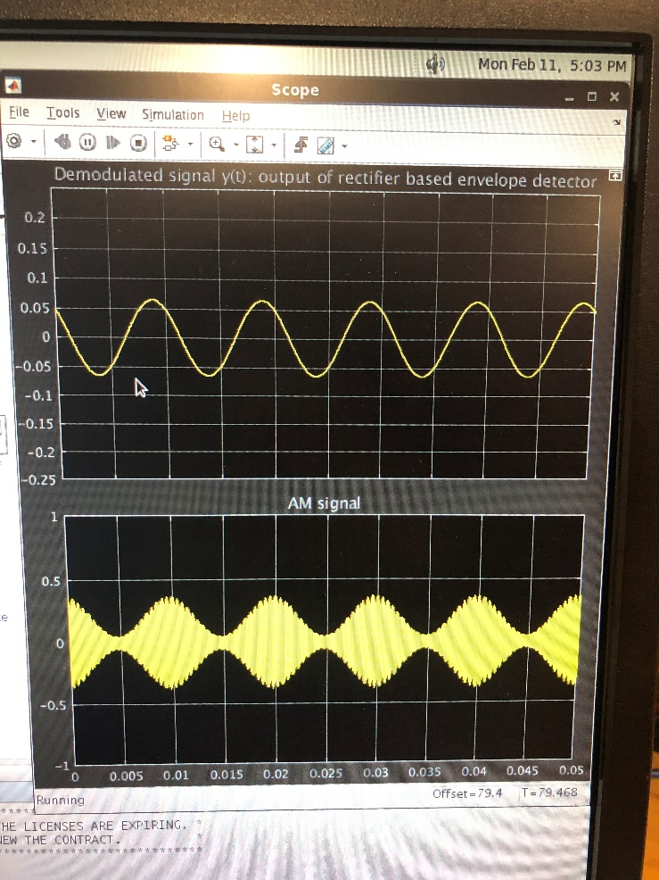

# **Hilbert Transform Based Envelope Detector**

# **Envelope and Coherent**